Georgian (1714 to 1837)
Georgian style embraces a century under the reign of three Georges and is often divided into the Palladian, early and late Georgian periods. The style was partly a reaction to baroque which George I loathed
The three phases of Georgian are a continuum of each other. As the century progressed, the style became lighter and lighter in terms of colours and decoration and eventually became regency style.
Taking an interest in fashion and interiors was very much the order of the day; entertaining was becoming more popular and print books containing designs and architectural models were becoming available to the public for the first time.
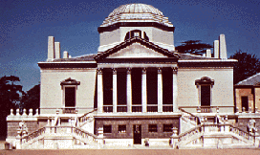
The term Georgian refers to the historic period of all of the ruling King Georges of England and Ireland from 1714-1830. Under the Hanoverian kings Great Britain and Ireland saw the wholesale adoption of Classicism. It was the outward expression of a burgeoning admiration for the learning of Greece and Rome. Aristocrats and fashionable architects rounded out their education with a Grand Tour of Europe, viewing and sometimes sketching Classical monuments.
Georgian buildings are characterised by their symmetry and regularity of detail. Great houses and public buildings were fronted with massive pediments and colonnades inspired by ancient Greek and Roman temples.
Features of Palladian architecture
Georgian architecture was widely disseminated in the English colonies of the time. In the American colonies ,colonial Georgian blended with the Neo palladian style to become known more broadly as 'Federal style architecture'. Georgian buildings were also constructed of wood with clapboards; even columns were made of timber, framed up, and turned on an over-sized lathe. Brown university, Harvard university, and the College of William and Mary, offer leading examples of Georgian architecture in the Americas.
• Strict adherence to the rules of proportion. Palladio was heavily influenced by the writing of Roman architect Vitruvius, who believed there was a perfect symmetry and proportion in nature, which could be replicated in buildings. By studying the work of Vitruvius, and ruins of ancient buildings, Palladio created a set of architectural rules.
• Symmetry - one half of the building, or at least the façade, is a mirror image of the other.
• Columns topped with capitals carved into the shape of acanthus leaves, often referred to as Corinthian columns.
• Scallop shell motifs.
• Pediments over doors and windows - these are triangular, often containing some form of decoration.
Examples of Palladian architecture
• Chiswick House, West London, is usually regarded as the best example, being built by the leader in Palladian fashion, Lord Burlington, with interiors designed by William Kent.
• Clandon Park, Surrey, was designed by a Venetian architect and built in 1720 for Lord Onslow.
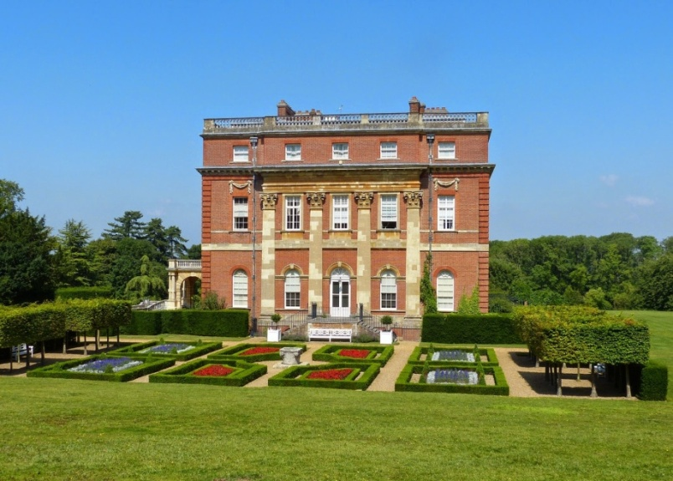
Clandon Park
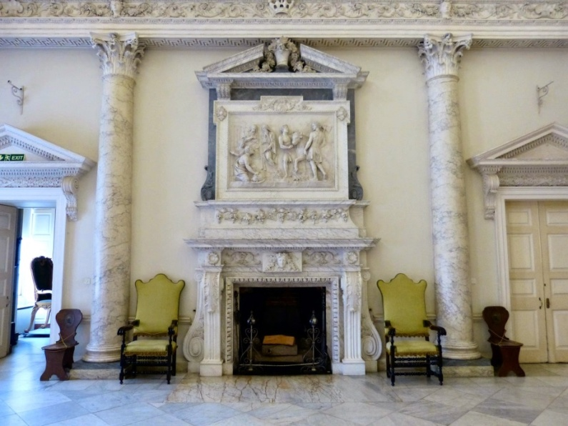
The entrance hall, Clandon Park
The Early Georgian period (1714-1750) saw a revival of Palladianism. The excesses of the Baroque had created a distaste for over-decoration and Andreq Palladio's Renaissance villas were admired as reflecting the pure lines of Classical architecture. There was a political element to this change of taste. Baroque was associated with the Counter-Reformation. The Hanoverians were a firmly Protestant dynasty. LordBurligton, who designed the fine villa above for himself at Chiswick, was a leader of the Palladian Movement.
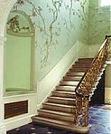
Late Georgian fashion was more flexible. Within a symmetrical exterior, there might be Rococo interiors with delicate, flowing decoration.Some architects experimented with a largely unconvincing Gothic revival, rather like a poor stage set, or with Chinoiserie and other exotica. British involvement in India had brought contact with Mughal architecture. The first attempt to imitate it was the house at Sezincote, Gloucestershire, built in 1803 for Sir Charles Cockerell, who had served in the East India Company. It was followed by the Royal pavillion at Brighton, redesigned in Indian style for George, Prince of Wales from 1815, with Chinese-influenced interiors.
Robert Adam developed the concept of an integrated interior with walls, ceiling, carpet and furniture all designed as a single scheme. Refusing to be confined in the Palladian straitjacket, he borrowed Byzantine, Italian Baroque and even Etruscan motifs, as well as those of Ancient Greece and Rome. His brightly-coloured interiors were covered in refined ornamentation. The Adamesque style proved highly influential. This recrecreation of an Adamesque room at the Geffrye Museum can be viewed in an interactive panorama.
Regency style (1811-1830*) is characterised by fluted pilasters replacing full-bodied columns and a general refinement of Classical details to mere decorative motifs. At the same time some architects were embracing a purer Classicism in the Greek Revival style.
*Before reigning as George IV (1820-30), George was Prince Regent (1811-20). Generally his reign is lumped together with his regency in dating the style.
Common Building Types: Houses, schools, courthouses
The Georgian style, identified by its symmetrical composition and formal, classical details, was the most prevalent style in the English colonies throughout the 18th century. The Georgian style arrived in America via British architectural building manuals called pattern books around 1700. While the Georgian style was popular in England in the 17th and 18th centuries, it is based on the classical forms of the earlier Italian Renaissance period. English master architects Inigo Jones, Christopher Wren and James Gibbs, inspired by the classicism of the Italian Renaissance developed the Georgian style in England. As the style spread to the colonies, it reflected a period of colonial growth and prosperity and a desire for more formally designed buildings.
A typical Georgian house in Pennsylvania is a stone or brick two-story building with a side-gabled roof and a symmetrical arrangement of windows and doors on the front façade. Usually 5 bays (or openings) across with a center door, the style also commonly features a pedimented or crowned front entrance with flanking pilasters. Other commonly seen details are multi-paned sliding sash windows, often in a 6 light over 6 light pattern, a dentiled cornice, and decorative quoins at the corners of the building. Smaller Georgian buildings might be only 3 bays across, and feature either a center door or side door. The side door version is called a "Two-thirds Georgian" since it follows the Georgian style but lacks two of the usual five bays across the front. This variant of the style, adapted to an urban setting, appears in rowhouse or townhouse form in the state’s early cities. Some Georgian buildings in Pennsylvania were built with a pent roof between the first and second stories, although this was not the common form. Another regional variation of the style is the hooded front door, marked by a shallow roof projecting from the decorative crown at the front entry.
Elements of the Georgian style in various vernacular forms appear on buildings in Pennsylvania throughout the 18th century and beyond.
- Symmetrical form and fenestration (window placement)
2. Multi-pane windows (6-20 panes in each sash)
- 3. Side-gabled or hipped roof
4. Stone or brick walls
5. Transom window over paneled front door
6. Pediment or crown and pilasters at door way
7. Cornice with dentils
8. Water table or belt course
9. Corner quoins
10. Large Exterior Symmetrical

An explosion of styles
The Georgians were not afraid to experiment and explore architectural alternatives to the classical form. The late eighteenth and early nineteenth centuries saw the emergence of Gothic revival and the Regency style while the incorporation of exotic ideas reached its zenith in the Brighton Pavilion.
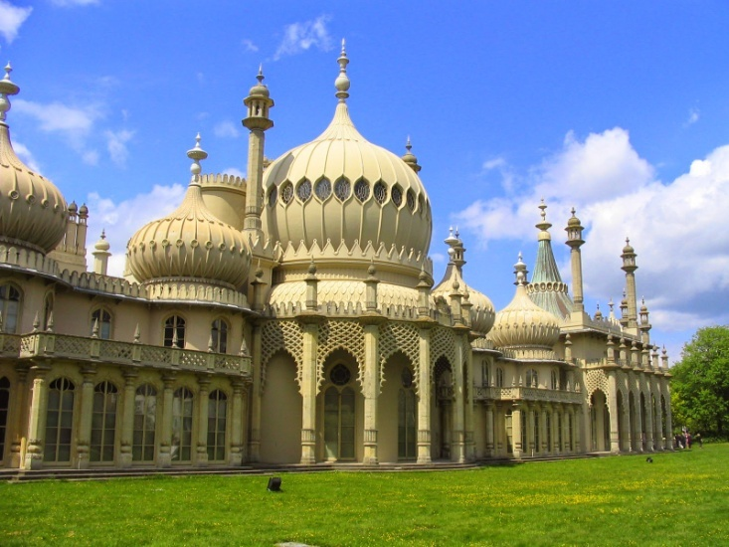
Brighton Pavilion
Gothic revival
The Gothic style, firmly rooted in the medieval period, is celebrated in numerous churches and cathedrals across Britain. It made a resurgence in the late eighteenth century, most famously at Strawberry Hill, built by writer Horace Walpole (1717-1797).
Here, in Twickenham, he built his “little Gothic castle”. Its battlements and towers rapidly became a tourist attraction, although he restricted entry to just four people per day, and no children. The popularity of the house, and the revived Gothic style, opened the way for the more significant Gothic revivals of the mid-nineteenth century.
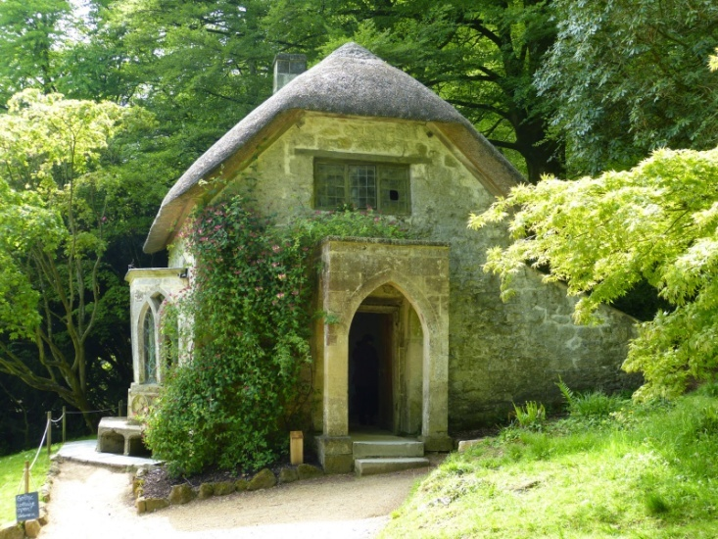
Gothic cottage, Stourhead
The Regency style
The Georgian architectural legacy stretches far beyond grand houses and public buildings. Numerous towns and cities enjoy elegant rows of terraced houses built in what is now called the Regency Style.
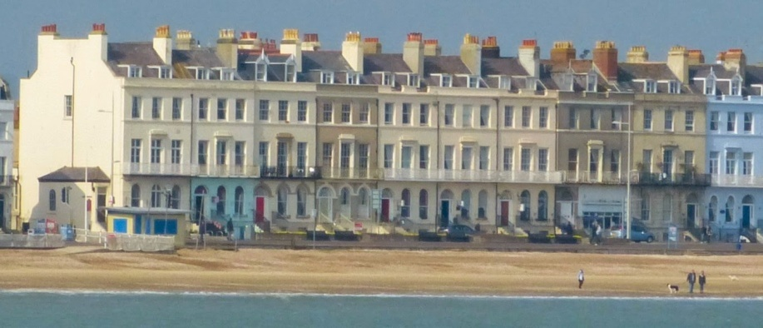
Part of Weymouth Esplanade
Much of Bath, large swathes of London including Regent Street, the Esplanade in Weymouth - all these are surviving examples of the Regency Style. It began in Bath, where John Wood the Elder (1704-1754) combined the Palladian style with his own ideas on town planning.
The world-renowned Royal Crescent, probably the most photographed example of Georgian architecture, was built in 1767-1775 by John Wood the Younger, who continued the architectural vision of his father.
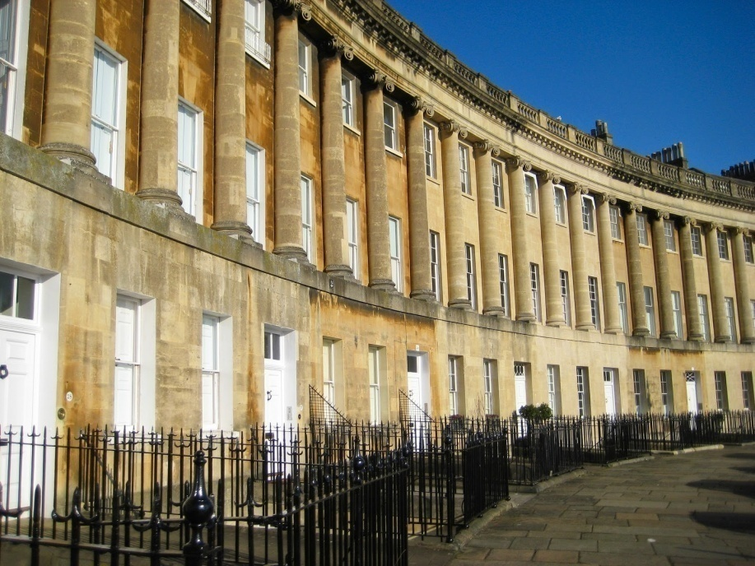
Royal Crescent, Bath
John Nash (1752-1835) took Wood’s ideas and applied them in his work for the Prince Regent, which began in earnest in 1810. His major project was the route linking Regent’s Park to Carlton House, a major exercise in town planning.
Brighton Pavilion
While the Georgian architecture of the eighteenth century was heavily influenced by classical Greek and Roman forms, the early nineteenth century began to absorb more exotic ideas.
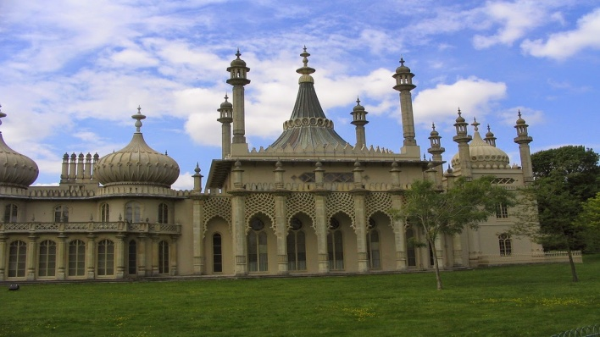
Brighton Pavilion

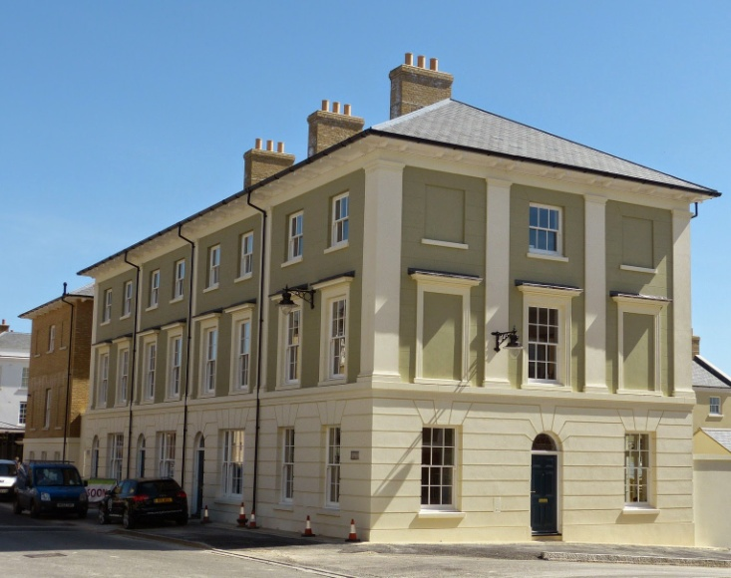

The difference between Palladian and Neo-classical architecture
At first glance, the building constructed in the Palladian style is very similar to a Neo-classical design. Both have pillars; both have symmetry; both have strong classical lines.
The date of construction might be a clue, with Palladian preceding Neo-classical, but there was a considerable period of overlap.
The biggest difference, which might be hard to spot, is that Palladian architecture adhered to the rules of proportion. Neo-classical architects, such as Robert Adam, made a conscious decision to break free of the restrictions these rules imposed. The results were lighter, more elegant constructions which, for many, represent the pinnacle of Georgian architectural achievement.
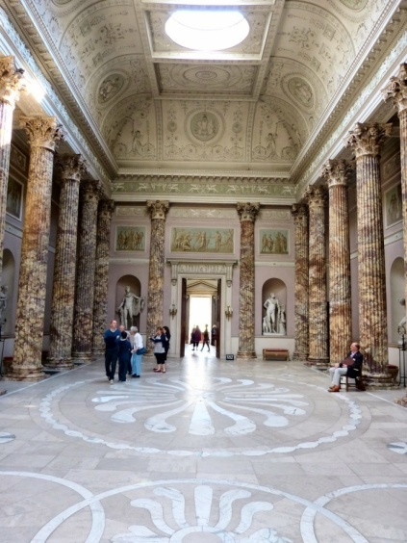 The Marble Hall, Kedleston Hall,
designed by Robert Adam

- 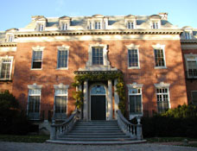

- 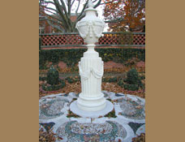
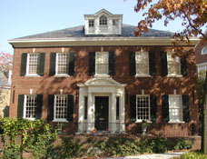
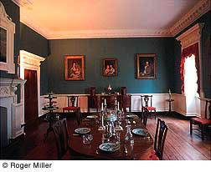
Interior spaces in Georgian era
In general, homes got bigger, more comfortable and more stylish than those built just a few decades before. The interior elements, material, colors and decorative arts of this theme varied much more regionally than did the architecture. For example, brick was used more for the Southern grand homes because the Negro slaves made this material from scratch. Bricks were very expensive to buy. Wood was the most common home building material in New England.
The central hall axis is important to the design. It was also important to the function of the house. It meant that guests could easily flow from room to room, depending on the activity. New rooms were developed to house new activities.
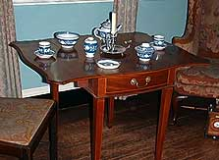
The pursuit of classical learning was important; library room was there, to display the conquest of learning (even if the books were blank or just dummy covers).. A larger dining room table was developed with many leaves to accommodate the dining of "polite society". Comfortable dining room chairs were created as dinners became long, drawn out affairs.The tea table was invented for the serious matter of enjoying and consuming one's tea.
- harmony and symmetry were the major characteristics of these era.
- Early Georgian colour schemes include burgundy, sage green and blue grey but, as the style developed, they became lighter and included pea green, sky or Wedgwood blue, soft grey, dusky pink and a flat white or stone.
- Floors use to be bare floorboards covered with Oriental rugs. Grander houses had stone or marble floors in pale colours, perhaps a keystone pattern.
- Walls were panelled but the panelling only reached dado height and the plaster above was either painted or papered.
- Mouldings were intricate - ceilings might have ribbons and swags, classical figures and urns.
- For soft furnishings glazed cotton fabrics with small sprigs of flowers were used. The same fabric would have been used for both the upholstery and curtains. Armchairs and divans often had loose covers made from cheap ticking or striped linen, which were removed for special occasions. Curtains often had pagoda style pelmets on top.
- Furniture was delicate - wing chairs and chairs with hoop or shield backs were typical.
- Fireplaces were the focal point of a room. They were elegant with basket grates, cast iron backs and decorated fronts featuring swags, urns, and medallions, perhaps flanked with classical pillars.
- Decorative objects included screens, fans, porcelain and lacquerwork from the Orient and bronze ornaments. Pictures hanged in formal groupings, flanking the fireplace.

Shape is a defining characteristic of the Georgian style.
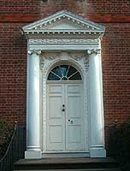
The square is prominent, and shapes are Classical, balanced and of course proportional. A geometric pattern of linked rectangles or squares is also found when looking at floor plans, as is the center hall axis.Windows are also evenly spaced squares or rectangles, often a large rectangular window with a centered semi-circle over the top (a Venetian window).Roofs are pitched or hipped. This refers to a triangle shape with the top cut off. The triangle is critical not only in roofing but in doorways.Almost every true Georgian house door is a pediment, classical in proportion, and supported by pilasters. Arches are prominent over the top of doors, and usually contain a glass fan to allow more light in.
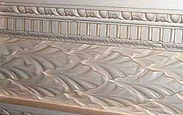
Motifs - Classical symbols from the Roman vocabulary of architectural elements were prevalent, such as delicate acanthus leaves, rosettes, and scallop shells. Fruits and plants became popular as global trading introduced new types of vegetation and exotic fruits.
Ornaments and Decoration - Early use of egg and dart molding and capped dentillation prevailed. We also find swags, roundels, Aesops fables, oriental elements, and other classical follies.
Patterns - Diaper, trellis and latticework patterns were popular. Stripes also became more widely used.
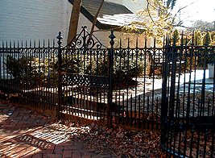
Brick - For those wealthy enough to afford the labor of making their own bricks, this was the coveted building material. Laying the bricks perpendicular to the house was a real show of wealth and contributed to the solid building that allows these homes to remain in existence today. Metal - This was used primarily for weather vanes, gates, fences and hardware.
Glass - Classic transom lights are an important feature of the Georgian door. The semi-circular shape and fan design suits the geometric style of the door and allows for maximum light.
Wood - This was the most common building material used in 18th century America. This material was widely used for paneling, wainscoting, moldings, trims, stairways, fences and gates.
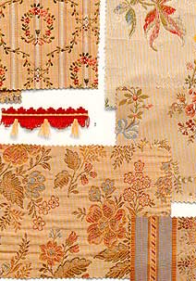
Textiles - The advent of the printing on cloth (chintz), allowed for a higher quality and less expensive fabric. This invention proliferates the popularity of foreign patterns and motifs from chinoiserie designs.

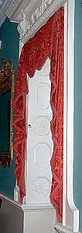

Drapery - More ornate, decorative treatments prevailed. Pelmets or cornices, swags and jabots are used as overhangings for the under curtains.

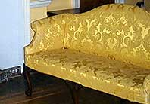
Upholstery - Line and silk damasks were coordinated with the wall hangings and curtains. Finer fabrics replaced the "homespun" fabrics.

Favored colors - "included magenta and crimson, deep green, dark blue, pastel pinks and blues". (The Style Sourcebook, pg.76) Tapestries of floral patterns are popular for seat and cushion upholstery.

Material Finishes
Paint - Usually a single coat over plaster or wood. Mid sheen and oil based paints became more popular as the century progressed.
Wallpaper - Although rare, this was used as a background to a painting or other ornamentation. Flocked or hand blocked styles are more prevalent in the later part of the century.
Decorative Accessories
Lighting - The most prominent chandeliers were hanging candle holders made of iron and wood. Their use was reserved only for the wealthiest because the candles made of bees wax were very expensive. The chandelier of metal and glass was very rare. Sconces were a decorative light source. Only minimal light existed on the exterior.
China and Porcelain - Imported china cups and teapots were essential items for the social elite. Most china was imported. The delft tiles and porcelain were made in this country and were of a more crude nature than the imported Wedgewoods of England.
As the Georgian style grew in popularity in British America, so did the size of the house, which meant that better building techniques were required.
It is astounding that most of the homes built during this time were put together from representations in books and memories from foreign travel. Amazingly, these structures are very sturdy and solid. This is also due to the classical, square shape that has a solid foundation.
Ceilings - Ceilings of plaster were the most common. Later in the 18th century the elaborately molded, carved or decorated ceiling was popular. Often in the more formal rooms there was a central ornate medallion panel.
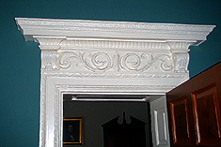
Doors - Heavily molded doors are a design of the 18th century Georgian style. Classical surrounds were popular. These were made mostly of wood, and later of stone or brick. The front door is important because it shows off the fancy and elaborate center hall staircase.
Columns - These are visible in porticos, front door surrounds and fireplaces, but typically in the form of a classical pilaster.
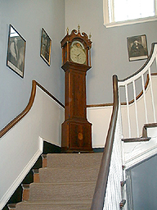
Fireplaces - These became smaller and focal points of the entertaining room. "An important factor in this evolution was the separation of the kitchen and the social rooms which left the fireplace unconstrained by the needs of cooking". (The Elements of Style, pg. 121) They were heavily decorated for the most part with carved wooded ornaments, pilasters and classical surrounds. In the mid 1700's the marble fireplace appeared.
Stairs - The central hall staircase is a key element of the Georgian style and classic central hall floor plan. The staircases tend to be open-string and have molded, turned and carved handrails and elaborate balusters. Often the sides of the staircases are paneled or have wainscoting and pilasters, and the side-ends are carved. There is often a second staircase used for more utilitarian purposes. The staircases are made of wood, as are the railings. Balustrades are also wooded.
Windows - By the 1730's the weighted wooden sash windows were starting to appear. Flat and dormer windows are part of this time period. Windows are more symmetric and in greater numbers. Internal shutters were also popular.
Walls - In general, the more formal the room the more decoration on the walls. From applied wood molding onto plaster sheath in imitation panels, to elaborate fretwork, skirting boards, and pilasters, ornamentation on the walls is a trade mark of the Georgian style.
Floors - Almost exclusively the floors were wood, generally pine planks, without stain or varnish. Painted floor cloths were very common. The use of finer rugs was rare and did not become more common until after the Revolutionary war.
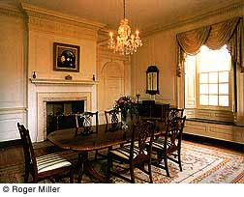
Furniture - Built in furniture became more popular and was prestigious. The cupboard, which housed the valuables such as silver, tea, and cloth, was prominent. A more decorative carved glass front corner cabinet visually showcased coveted items of wealth. At the beginning of the 18th century furniture was rather sparse. The improvements to and inventions of furniture really proliferated with the emerging social class. Chairs were no longer simply pushed against the wall but were designed for greater seating comfort and lounging. Small tables for dining were replaced with larger, many-leaved octagonals for sharing meals. Cupboards were no longer just for storing precious items, they were needed to display trinkets, dishes, food and libations. Armoires were created to handle the increase in clothing needed for all the refined activities.
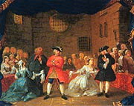
The story of color in the 18th century variesbroadly within the Georgian period style, depending on the year and the country. In general the colors went from a more subdued, narrow palate to a quite expansive bright expression.

The story of color in this period is really one of form dictating function. In other words, the emerging enlightenment and return to classicism coincided with necessity. For centuries, English homes of wood and timber were dark with little light and small living spaces. After the great Fire of London, the building codes in England were established and materials and forms were changed forever. Those building codes echoed the very philosophies of the Georgian enlightenment. The buildings of the new Palladian forms literally "let the light in". From the numerous facades and Venetian windows to the open floor plan, the format demanded a more natural, light color scheme.
The new building types and color preferences coincided with new advances in paint technology and fashion. The paint production process was still costly and the materials rare. Limewash and Casein were still used primarily for walls and cheaper furniture. Fine furniture and paneling were still primarily of oak, which was never painted. However as oak became more expensive, it became fashionable to use paint over the paneling, woodcarvings, and furniture. At first it was used to cover up grains of inferior woods, then later on for protection from the elements. This brought about the use of brighter colors for interiors.
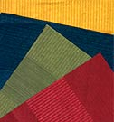
The colors of the beginning of 18th Century Georgian Style were colors like "Prussian blue, red lead, vermilion, and verdigris." (Living Colors, pg.45)
By the mid 18th century, most Georgian London homes of the more affluent upper class began to use oil paints made from a mix of linseed oil, turpentine, and a ground pigment. The oil colors were more vivid and bright! This new brightness was of great use as more entertaining was happening and "polite society" needed to be lit for their follies.
Since paint was expensive, the most brightly painted rooms were those used for entertaining and show. Dining rooms, drawing rooms, guest bedchambers, and center halls were lavishly coated with beautiful oil paints. When mixed with the growing use of precious metals (candle holders, frames, cutlery, etc.), reflecting mirrors, crystal and porcelain, the effect was dazzling.
Our American counterparts of this time period didn't get all of this refinement. The colonial fashion-conscious had to import their earth pigments and linseed. Few craftsmen in the colonies were paint experts so new sets of fashionable colors were popularized. By using milk or buttermilk, some lime, and native earth pigments they created some very interesting and sometimes beautiful colors.
In general the colors move from muddy, medium values to more pure colors chronologically. As more paints (actually the pigment materials) were imported, the choices broadened and the colors were more saturated. The iconic color is probably medium to deep green. The color schemes of most Georgian homes were decided upon by what they could actually get their hands on, and not by personal choice. Probably the Analogous color scheme was most widely used in early Georgian Style and later the Tetrad. (Again, color choices were dictated by what was available, so this is tricky).
The story of the colors is not limited to just paint. We focus on paint since it is a single medium that can provide a great deal of information about style choices. However, fabrics and carpets were also very important color trend stories. As technology developed, chintz (printed fabric) became widely available and was very colorful. Rugs also made a big color impression, first the imported rugs from the Orient, and then the hand knotted rugs from England set striking new color schemes.
Carved wood and plaster were also part of the overall color scheme and will be addressed in the Materials and Texture sections.
So, everything got bigger when the stylistic changes shifted from Baroque to Georgian. Compared to dwellings built just a few years before this style became fashionable, the Georgian style appears enormous in relative scale. As the size increased so did the numbers and sizes of the windows. More light and bigger rooms offered an opportunity to enterprising architects and the emerging profession of interior designers. When looking at Georgian style interiors, look at the architectural elements that dominate the living spaces-large fireplaces, huge staircases, grand entrances, and balanced proportioned rectilinear rooms. The appropriate textiles and wall coverings need to be of large patterns and scale to achieve a balance with the size of the elements. Larger pieces of furniture are proportionate to this space size; however, elegant groupings of smaller chairs and tables bring about a good visual balance.
Examples of Georgian architecture
A Georgian house in Salisbury

18th Century view of the Georgian Royal Exchange in Dublin; one of "Malton's views of Dublin"

Massachusetts Hall at Harvard University

A former guildhall in Dunfermline, Scotland built around 1807 and 1811

- George Hepplewhite - furniture maker in the late Georgian period
- Thomas Chippendale - cabinet maker renowned during the middle Georgian period

